NAME: **Ibrar Babar**

Roll No: 19P-0104

Subject: DLD

BS(CS): SECTION (B)

ASSIGNMENT: [6]

**{Sir Shakir Ullah}**

**Question: [1];**

1. Draw the waveform of the following Design 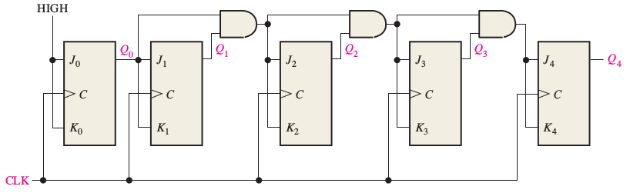

**SOLUTION:**



